UPCOMING WESTERN MASS LEGISLATIVE MEETINGS
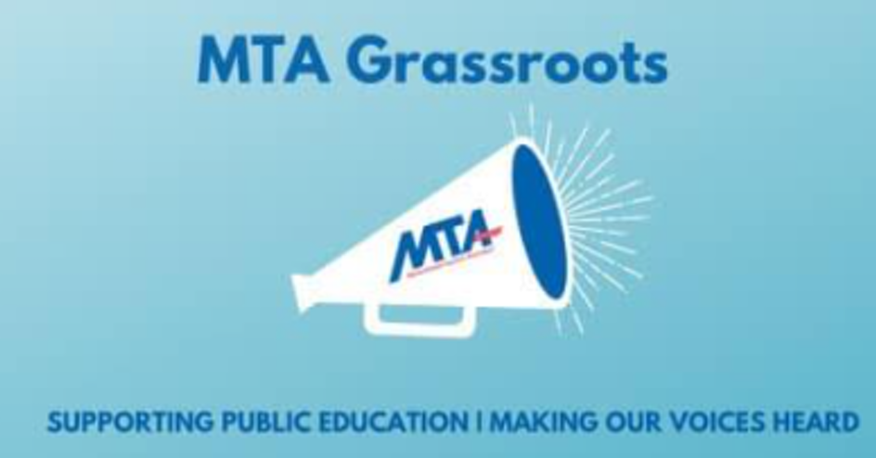
Thurs. April 8 @ 4:30pm – REGISTER HERE
w/ State Senator Adam Hinds, and State Representatives Tricia Farley-Bouvier, and Smitty Pignatelli
Mon. April 12 @ 4pm – REGISTER HERE
w/ State Senators Jo Comerford, and State Representatives Natalie Blais, Mindy Domb, Paul Mark, Lindsay Sabadosa, Daniel Carey, and Kelly Pease
Thurs. April 29 @ 5pm – REGISTER HERE
w/ State Representatives Brian Ashe, Mike Finn, Jacob Oliveira, Angelo Puppolo, Carlos Gonzalez and Orlando Ramos
Wed. May 5 @ 5pm – REGISTER HERE
w/ State Senator Adam Gomez
Higher Education activists are especially welcome to these forums to educate legislators about state budget issues on community college and university campuses, including the need for improvements to wages for adjuncts & part time faculty, the funding needed for COVID recovery and safer campuses, problems with deferred maintenance and infrastructure, and challenges facing your campus.
Get more info on MTA’s legislative priorities and actions HERE.

